Uploading manual activity to Strava App

- This can be used for runs / walks / cycles done on indoor bikes, treadmills etc.

- Open App
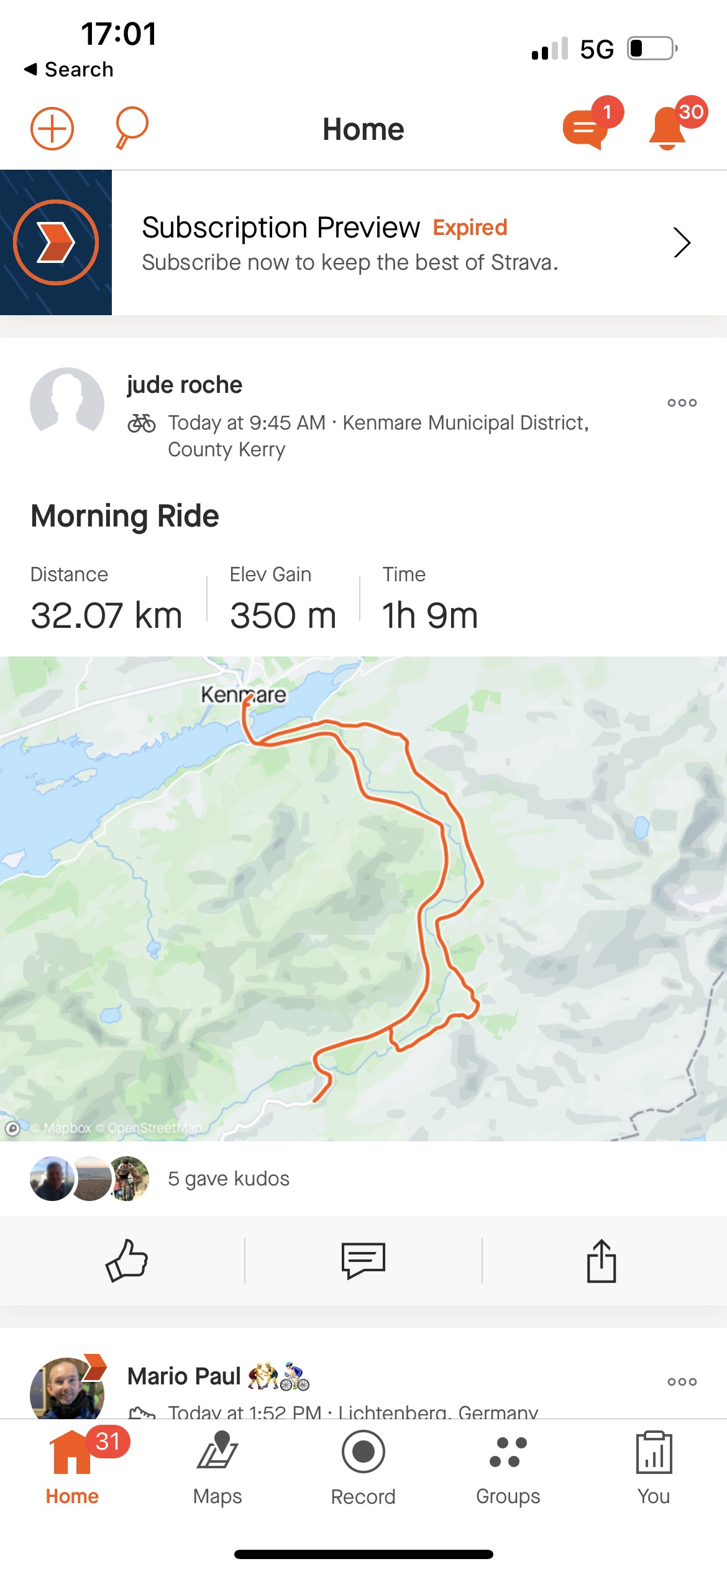

- Click top lefthand corner (+)
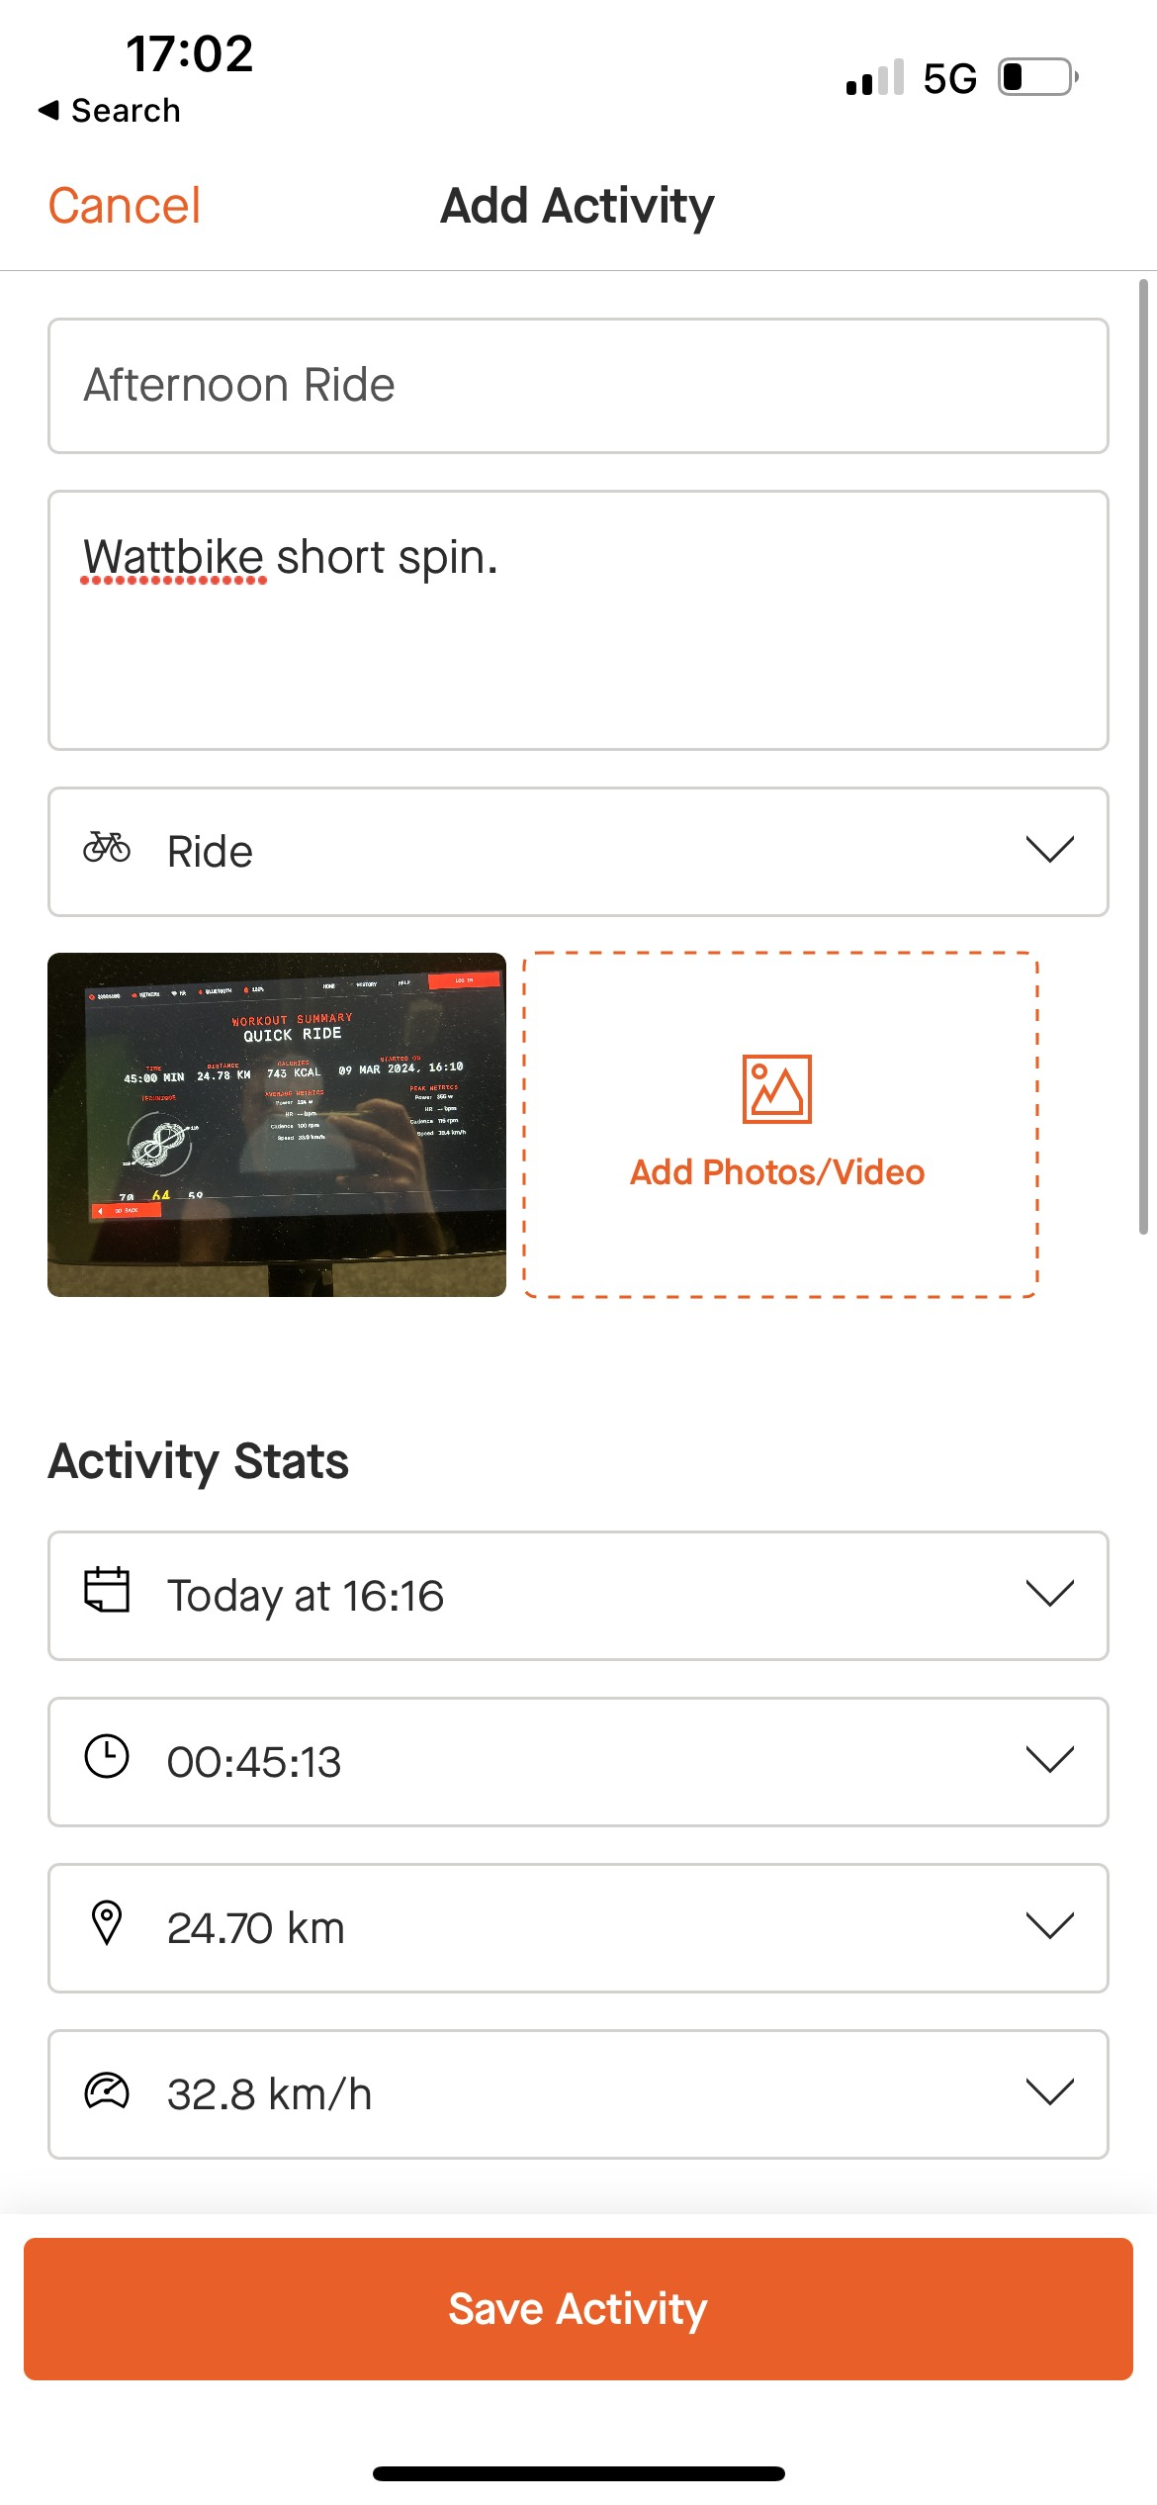

- Insert details of exercise as above and save!

