**NEW TO STRAVA? HERE’S EVERYTHING YOU NEED TO GET STARTED!**

It’s never easy picking a fitness tracking app, especially when there are so many to choose from. Not only do you need to choose one that’s compatible with your GPS cycling computer or smartphone, but there’s also the question of which one has the best features for your needs. Not to mention which one is most popular with your friends – cycling is always more fun when you can do it in good company!

Irelands Fittest ICU’s app of choice is Strava https://www.strava.com .

**Step One – Set up your Strava account**

If you don’t yet have an account, head over to the Strava website or download the smartphone app to get started. You can choose to set up your account using your email address or by connecting with Google, Apple or Facebook – both options are easy to do and only take a minute. A basic Strava account is free and lets you do everything described in this guide. If you want to unlock advanced heart rate analysis, personalized fitness tracking, filtered leader-boards and more then you can subscribe to Summit membership later on.

Join Irelands Fittest ICU challenge Group for your workplace (set up by each individual group)

SVUH Strava Group

**Step Two – Sync your GPS cycle computer or watch**

Once you have created your Strava account, it’s time to get everything connected. If you use a GPS device, you’re in luck: Strava works well with Garmin and Wahoo (to name but a few). Rides, walks etc. that you upload to your device’s website will automatically be sent to Strava each time you sync. Head over to the Upload page to connect these services to Strava once, and that’s it – all future runs will appear on Strava. You can continue to use your device and there’s no need to use the smartphone app to record your runs. However, you can also use your phone if you don’t have access to a smartwatch.

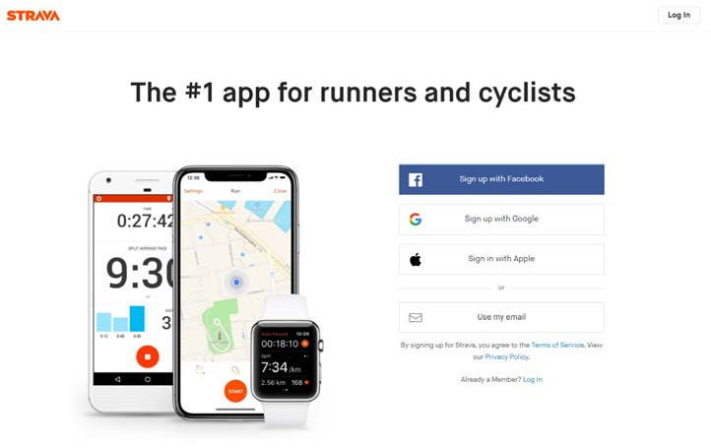

If you’re just using your smartphone, then joining Strava is a lot easier. All you need to do is download the Strava app and start recording your rides with it...

Have a look at https://support.strava.com/hc/en-us/articles/223297187-How-to-get-your-Activities-to-Strava for more information.

**Step Three – Import your old rides**

... but what about all of those old rides, PRs and races – the ones that are locked away in your old favourite fitness app? Good news, these can be imported to Strava too – it’s quick and simple to do, and works great regardless of if you ride with a watch or a smartphone app. Have a look at https://support.strava.com/hc/en- us/articles/216918007-Bulk-Uploading-Activities-to-Strava for more information.

**Step Four – sync services and social media**

Connect to social media sites, such as Instagram, Google and Facebook. Enabling a connection allows you to share your activities outside of Strava.

**Step Five – go ride!**

The club’s Strava homepage lets you compare your rides with others in the club and also provides details of any challenges or competitions that are running. Have a look at the leader board to see what other club members have been doing.

**How to record exercise session on Strava**

1. **Open App**
2. **Click RECORD on bottom of the screen. This will give you the time, average speed and distance travelled.**

1. **When finished your session click end and upload. Be sure to share on your ICU’s Group page to encourage others along their own journey! Remember**
2. **Remember – each point counts, no matter how slow or fast! Be proud.**