Infographic on how to set up Strava Group for your ICU

Note: at this time, clubs can only be created via the Strava website, not via the app.

Click on the link below to get to Club Search page.
1. From the Club Search page, click on 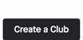 (in the upper right).
2. Fill out the required fields: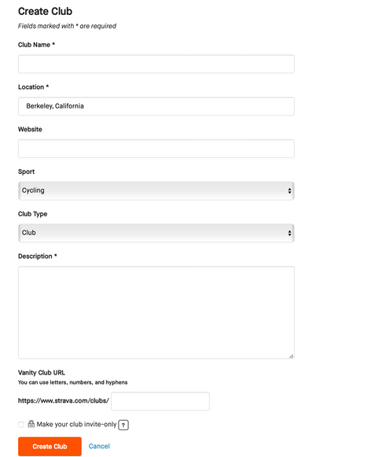

NOTE: If you do not want your club to be public, be sure to click. For invite only clubs, Athletes must request permission to join. Only admins can approve new Club members. Keep in mind that invite-only clubs are not invisible to non-members; they only require admin permission to join. However, recent activities, discussions, and private group events will be hidden from non-members. For public clubs, anyone can join.
3.Once you’re done, click and your club will be ready to go!
INVITING OTHERS TO YOUR CLUB:
To invite athletes through Strava, we require that you and the given athlete both be following each other. If this is the case, you can click the button. If not, you can comment on other athlete’s activities and include the link to your club to invite athletes through Strava. You can also share your club invite link through email or post the invite link on social media platforms. From the mobile device, you will see the following options:
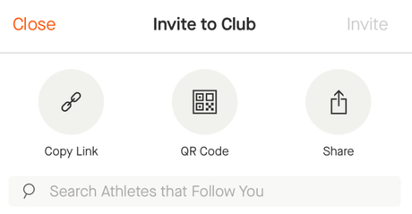

CLUB OWNERS & CLUB ADMINS:
Club Owners:
-> If you create the club, you will automatically be designated as the club owner
-> Only club owners can delete a club
-> At any time, owners can transfer ownership, revoke or give other club members admin status and remove club members. Hover over a member's name to reveal these options Club Owners and Admins:
-> can create club events
-> can change the club cover photo by clicking on the camera icon on the lower, right-hand side of the current cover photo
-> can change a club's profile photo by clicking the '+' sign displayed on the current photo
-> have the ability to edit their club information by clicking the Edit Club button next to the club name
-> can accept members when they request to join (for invite only clubs)
CLUB POSTS:
This is a great place to engage with your members. Here you can post updates, info, nutrition and training tips, etc.
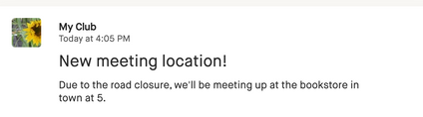Posts can be done from the web or app. On the web, go to your club, click the posts tab and click Create a Post:
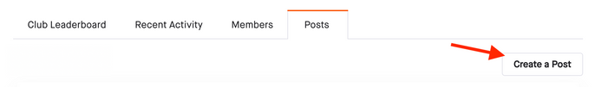
On the app, tap Groups (on the bottom) then choose Clubs. Open the Club in which you want to post. You can post something from the Club's main page or by opening the Posts tab, tapping the plus sign icon, and adding a post or photo. Click publish when ready.
